Deployment Manager: Qwik Start
30 minutes1 Credit

Rate Lab

GSP083

Overview
Deployment Manager is an infrastructure deployment service that automates the creation and management of Google Cloud Platform resources for you. Write flexible template and configuration files and use them to create deployments that have a variety of Cloud Platform services, such as Google Cloud Storage, Google Compute Engine, and Google Cloud SQL configured to work together.
This hands-on lab shows you how to use Deployment Manager to create a simple configuration file, use that file to create a deployment, then view deployment information on a manifest.

What you'll do
- Create a configuration
- Deploy the configuration
- Inspect the running environment
- View the deployment manifest

Setup

Before you click the Start Lab button
Read these instructions. Labs are timed and you cannot pause them. The timer, which starts when you click Start Lab, shows how long Cloud resources will be made available to you.
This Qwiklabs hands-on lab lets you do the lab activities yourself in a real cloud environment, not in a simulation or demo environment. It does so by giving you new, temporary credentials that you use to sign in and access the Google Cloud Platform for the duration of the lab.

What you need
To complete this lab, you need:
- Access to a standard internet browser (Chrome browser recommended).
- Time to complete the lab.
Note: If you already have your own personal GCP account or project, do not use it for this lab.

How to start your lab and sign in to the Console
- Click the Start Lab button. If you need to pay for the lab, a pop-up opens for you to select your payment method. On the left is a panel populated with the temporary credentials that you must use for this lab.
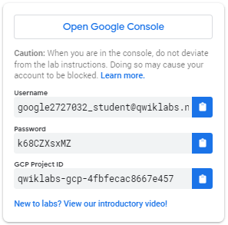
- Copy the username, and then click Open Google Console. The lab spins up resources, and then opens another tab that shows the Choose an account page.
Tip: Open the tabs in separate windows, side-by-side.
- On the Choose an account page, click Use Another Account.
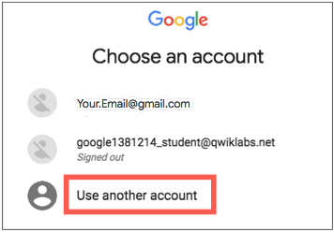
- The Sign in page opens. Paste the username that you copied from the Connection Details panel. Then copy and paste the password.
Important: You must use the credentials from the Connection Details panel. Do not use your Qwiklabs credentials. If you have your own GCP account, do not use it for this lab (avoids incurring charges).
- Click through the subsequent pages:
  - Accept the terms and conditions.
  - Do not add recovery options or two-factor authentication (because this is a temporary account).
  - Do not sign up for free trials.
After a few moments, the GCP console opens in this tab.
Note: You can view the menu with a list of GCP Products and Services by clicking the Navigation menu at the top-left, next to “Google Cloud Platform”. 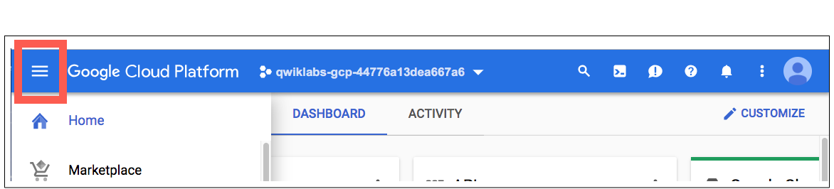

Activate Google Cloud Shell
Google Cloud Shell is a virtual machine that is loaded with development tools. It offers a persistent 5GB home directory and runs on the Google Cloud. Google Cloud Shell provides command-line access to your GCP resources.
- In GCP console, on the top right toolbar, click the Open Cloud Shell button.
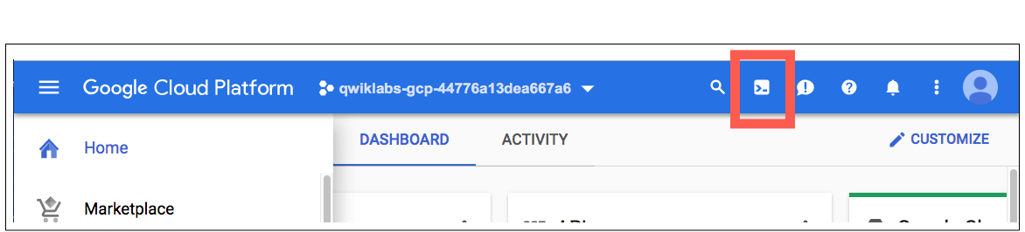
- In the dialog box that opens, click START CLOUD SHELL:
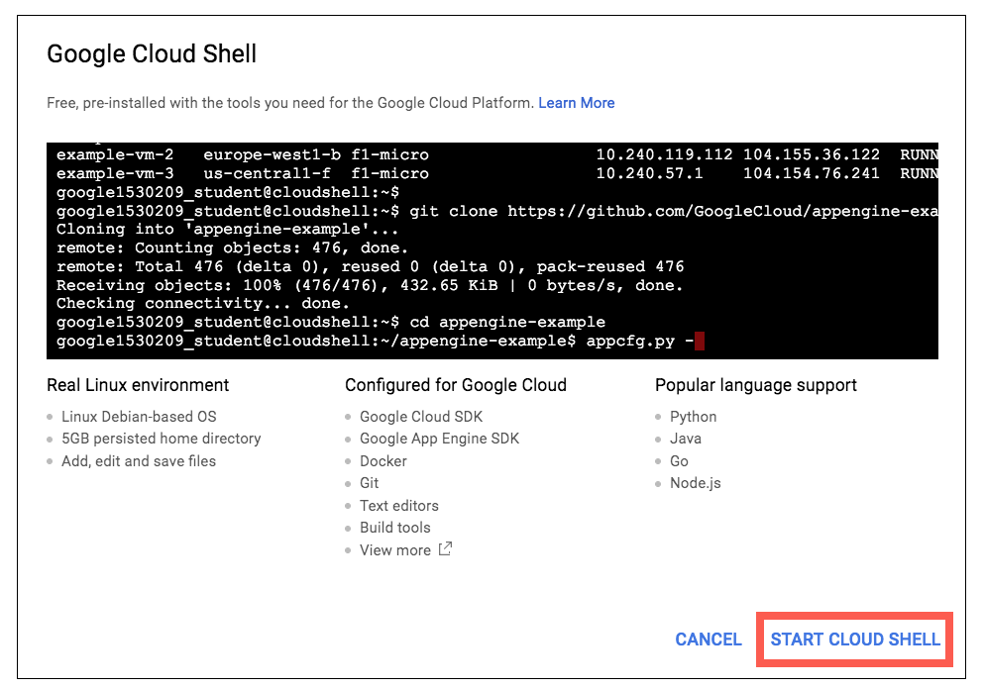
You can click "START CLOUD SHELL" immediately when the dialog box opens.
It takes a few moments to provision and connect to the environment. When you are connected, you are already authenticated, and the project is set to your PROJECT_ID. For example:
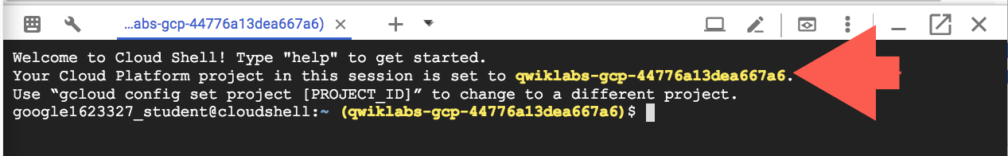
gcloud is the command-line tool for Google Cloud Platform. It comes pre-installed on Cloud Shell and supports tab-completion.
You can list the active account name with this command:
gcloud auth list
Output:
Credentialed accounts:
- <myaccount>@<mydomain>.com (active)
Example output:
Credentialed accounts:
- google1623327_student@qwiklabs.net
You can list the project ID with this command:
gcloud config list project
Output:
[core]
project = <project_ID>
Example output:
[core]
project = qwiklabs-gcp-44776a13dea667a6
Full documentation of gcloud is available on Google Cloud gcloud Overview.

Create a configuration
A configuration describes all the resources for a single deployment. A configuration is written in YAML syntax and lists each of the resources in your deployment. A resource can be any resource type defined in the resources list.
- In the Cloud Shell command line, create the vm.yaml file in nano text editor.
nano vm.yaml
- Paste the following content into the file:
resources:
- type: compute.v1.instance
name: vm-my-first-deployment
properties:
zone: us-central1-f
machineType: https://www.googleapis.com/compute/v1/projects/[MY_PROJECT]/zones/us-central1-f/machineTypes/f1-micro
disks:
- deviceName: boot
type: PERSISTENT
boot: true
autoDelete: true
initializeParams:
sourceImage: https://www.googleapis.com/compute/v1/projects/debian-cloud/global/images/family/[IMAGE_NAME]
networkInterfaces:
- network: https://www.googleapis.com/compute/v1/projects/[MY_PROJECT]/global/networks/default
# Access Config required to give the instance a public IP address
accessConfigs:
- name: External NAT
type: ONE_TO_ONE_NAT
- Still in nano, change the two instances of [MY_PROJECT] with your GCP Project ID found in the Connection Details section of the lab.
- Replace [IMAGE_NAME] with the latest image version: debian-9
Example content:
resources:
- type: compute.v1.instance
name: vm-my-first-deployment
properties:
zone: us-central1-f
machineType: https://www.googleapis.com/compute/v1/projects/qwiklabs-gcp-9d96af672da8a69f/zones/us-central1-f/machineTypes/f1-micro
disks:
- deviceName: boot
type: PERSISTENT
boot: true
autoDelete: true
initializeParams:
sourceImage: https://www.googleapis.com/compute/v1/projects/debian-cloud/global/images/family/debian-9
networkInterfaces:
- network: https://www.googleapis.com/compute/v1/projects/qwiklabs-gcp-9d96af672da8a69f/global/networks/default
# Access Config required to give the instance a public IP address
accessConfigs:
- name: External NAT
type: ONE_TO_ONE_NAT
- Exit nano (Ctrl+X) and Save (Y).
This simple configuration file you just created describes a deployment that contains one virtual machine instance with these properties:
- Zone: us-central1-f
- Machine type: f1-micro
- Root persistent disk: disk-my-first-deployment
- Image: debian-9
- A randomly assigned external IP address

Deploy your configuration
Now use the following command to deploy your configuration.
gcloud deployment-manager deployments create my-first-deployment --config vm.yaml
Wait for the operation to complete. While you wait, you should see a status message:
Waiting for create operation-1432319707382-516afeb5d00f1-b864f0e7-b7103978...done.
When the deployment is successfully created, you should see a message like:
Create operation operation-1432319707382-516afeb5d00f1-b864f0e7-b7103978 completed successfully.
NAME TYPE STATE ERRORS
vm-my-first-deployment compute.v1.instance COMPLETED -
Good job, you have completed your first deployment!

Test Completed Task
Click Check my progress to verify your performed task. If you have completed the task successfully you will granted with an assessment score.
Deploy your configuration.
Check my progress

Check out the new deployment
Use the following command to view information about your deployment.
gcloud deployment-manager deployments describe my-first-deployment
You should see a description of your deployment, including its start and end time, the deployment status, and any warnings or errors if applicable.
Example output:
id: '5572372507146542525'
insertTime: '2017-12-14T12:47:14.353-08:00'
manifest: manifest-1513284434359
name: my-first-deployment
operation:
endTime: '2017-12-14T12:47:31.659-08:00'
name: operation-1513284434171-56052fd249478-5e243958-c72313e7
operationType: insert
progress: 100
startTime: '2017-12-14T12:47:14.498-08:00'
status: DONE
user: gcpstaging9374_student@qwiklabs.net
NAME TYPE STATE INTENT
vm-my-first-deployment compute.v1.instance COMPLETED
Note: From this output you'll use the manifest value to view the deployment manifest in the next section. In the example output above, the manifest value is manifest-1513284434359.

View your deployment's manifest
A manifest is a read-only file that describes a deployment's resources in detail. Deployment Manager creates the manifest and logs any errors or warnings that occurred during deployment, which makes the manifest useful for troubleshooting.
To view your deployment's manifest, enter the following command. Replace <manifest-[TIMESTAMP]> with the manifest value from the previous section.
gcloud deployment-manager manifests describe <manifest-[TIMESTAMP]> --deployment my-first-deployment

Test your Understanding
Below are multiple-choice questions to reinforce your understanding of this lab's concepts. Answer them to the best of your abilities.
Deployment configuration is written in ____ syntax and list each resource in your deployment.
checkYAML
Python
Jinja
Ruby
Submit
Deployment Manager is an infrastructure deployment service that automates the creation and management of Google Cloud Platform resources.
True

False

Congratulations!

